

Parent/ Carer Conferencing Form

Dear Parents/ Carers,
Please find a copy of your child’s Conferencing Report following a conversation/ meeting with your child’s class teacher. We welcome teacher to parent discussion about your child's school report so should you wish to speak with your child's class teacher or any other member of the Gorsefield staffing team regarding any further information upon receiving this report, please ring school on 01617259750 or email gorsefield@bury.gov.uk to make a mutually convenient time.

Attendance has been calculated from the start of this academic year
96%-100% Attendance
As you are aware, our school target for your child’s attendance is 96% and above. If your child's attendance is 96% or above, we would like to say well done and thank you for help and commitment in achieving this.
90-95.9% Attendance
If your child’s attendance is between 90-95.9%, this is below what expected from Bury Local Authority and what we expect as a school. We look forward to working in partnership with you to help this improve.
90% below Attendance
90% is considered ‘persistently absent’ throughout the academic year. If your child’s attendance is currently below 90%, this is below what expected from the local authority and by us at school. Following this you will receive a letter detailing your child’s attendance and we look forward to working in partnership with you to help this improve.
Name of Child
Class/ Year Group
Class Teacher
Special Educational Needs Status
Additional Support/ Intervention

Your child is in Rapid Risers and is currently accessing the Equals semi-formal curriculum.
Your child is working at pre key stage standards.
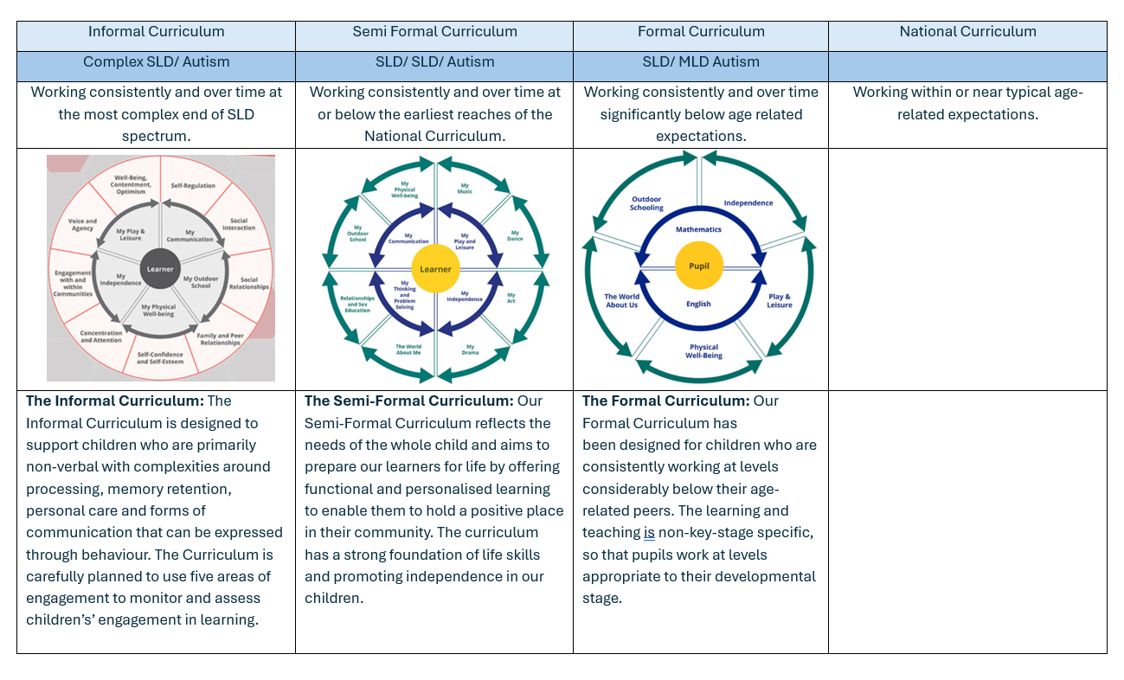


Area of Excellence
Term 1

Term 2

Grip Development Journey
Dominant Hand Preference | Assessment Point 1 | Assessment Point 2 | Assessment Point 3 | Assessment Point 4 | Assessment Point 5 | Assessment Point 6
Dominant Hand Preference | Palmar Supinate Grip | Digital Pronate Grasp | Static Tripod Grip | Triangulation Grip | Inverted Tripod Grip | Tripod/ Triangulation Grip
Left  Right | 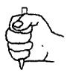 | 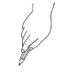 | 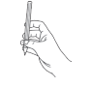 |  | 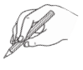 | 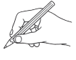
Term 1

Term 2

Term 3

WELLCOMM/ SALT
 | I am on section: | Now I can: | My next step is to:
Term 1

Term 2

Term 3

Read Write Inc Phonics
 | I know… | I am learning to…
Term 1

Term 2

Term 3

EQUALS Semi-Formal Curriculum
Guided  Accessing the curriculum through adult support and guided group learning. | Independent  Accessing the curriculum and completing learning without any adult support. | Applying  Able to access independently and apply skill to individual tasks, demonstrating enquiry skills | Adapt  Able to model/ show a peer to complete tasks and recognises connections and make links within and between their learning.
 | My Communication | My Art | My Independence
Term 1

Term 2

Term 3

Gorsefield Values
 |  |  | 
 | I overcame a barrier when… | I celebrated individual difference when... | I am embraced a challenge when…
Term 1

Term 2

Term 3

Personal Development and Behaviour
 | Attendance | Punctuality | Behaviour | Home Learning
Term 1 | 97.6%  (see colours above)
Term 2

Term 3

Teacher’s Comment

Term 1

Term 2

Parent/ Carer’s Comment

Term 1

Term 2

Signed:

Date:

